SCHOOL OF COMPUTER SCIENCE AND ARTIFICIAL INTELLIGENCE |  |  |  |  | DEPARTMENT OF COMPUTER SCIENCE ENGINEERING
ProgramName:B. Tech |  |  |  | Assignment Type: Lab |  |  | AcademicYear:2025-2026
CourseCoordinatorName |  |  |  | Venkataramana Veeramsetty
Instructor(s)Name |  |  |  | Dr. V. Venkataramana (Co-ordinator)  Dr. T. Sampath Kumar  Dr. Pramoda Patro  Dr. Brij Kishor Tiwari  Dr.J.Ravichander  Dr. Mohammand Ali Shaik  Dr. Anirodh Kumar  Mr. S.Naresh Kumar  Dr. RAJESH VELPULA  Mr. Kundhan Kumar  Ms. Ch.Rajitha  Mr. M Prakash  Mr. B.Raju  Intern 1 (Dharma teja)  Intern 2 (Sai Prasad)  Intern 3 (Sowmya)  NS_2 ( Mounika)
CourseCode |  |  | 24CS002PC215 | CourseTitle |  | AI Assisted Coding
Year/Sem |  |  | II/I | Regulation |  | R24
Date and Day  of Assignment |  |  | Week4 - Tuesday | Time(s)
Duration |  |  | 2 Hours | Applicableto  Batches
AssignmentNumber:8.2(Present assignment number)/24(Total number of assignments)
 | Q.No. | Question |  |  |  |  |  | ExpectedTime  to complete
 | 1 | Lab 8: Test-Driven Development with AI – Generating and Working with Test Cases  Lab Objectives:  - To introduce students to test-driven development (TDD) using AI code generation tools.  - To enable the generation of test cases before writing code implementations.  - To reinforce the importance of testing, validation, and error handling.  - To encourage writing clean and reliable code based on AI-generated test expectations.  Lab Outcomes (LOs):  After completing this lab, students will be able to:  - Use AI tools to write test cases for Python functions and classes.  - Implement functions based on test cases in a test-first development style.  - Use unittest or pytest to validate code correctness.  - Analyze the completeness and coverage of AI-generated tests.  - Compare AI-generated and manually written test cases for quality and logic  Task Description#1  Use AI to generate test cases for a function is_prime(n) and then implement the function.  Requirements:  - Only integers > 1 can be prime.  Check edge cases: 0, 1, 2, negative numbers, and large primes.  Expected Output#1  - A working prime checker that passes AI-generated tests using edge coverage.  - 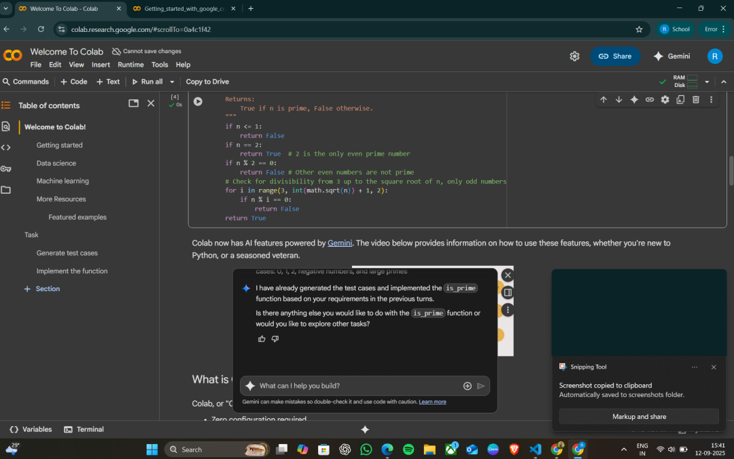  Task Description#2 (Loops)  - Ask AI to generate test cases for celsius_to_fahrenheit(c) and fahrenheit_to_celsius(f).  Requirements  - Validate known pairs: 0°C = 32°F, 100°C = 212°F.  - Include decimals and invalid inputs like strings or None  Expected Output#2  Dual conversion functions with complete test coverage and safe type handling  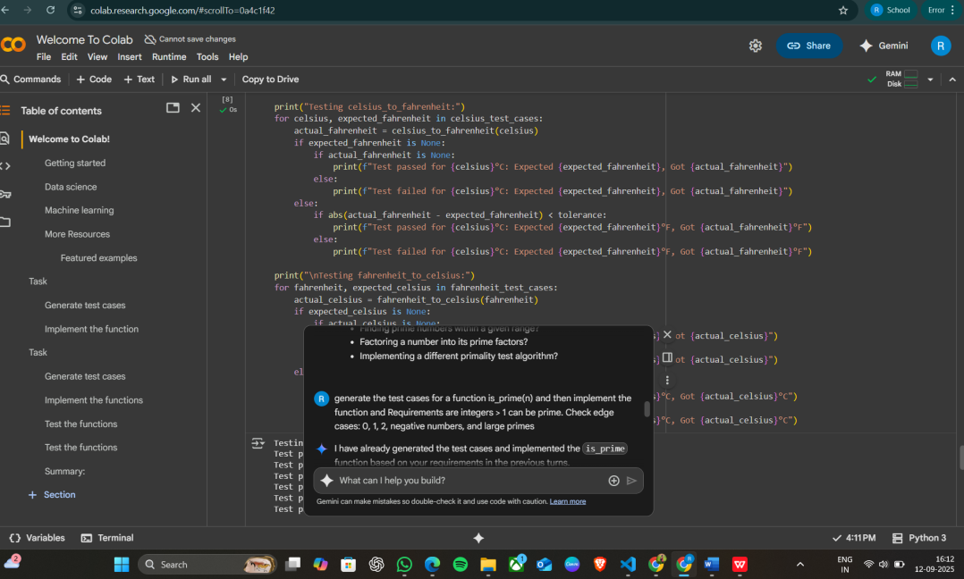  Task Description#3  Use AI to write test cases for a function count_words(text) that returns the number of words in a sentence.  Requirement  Handle normal text, multiple spaces, punctuation, and empty strings.  Expected Output#3  Accurate word count with robust test case validation.  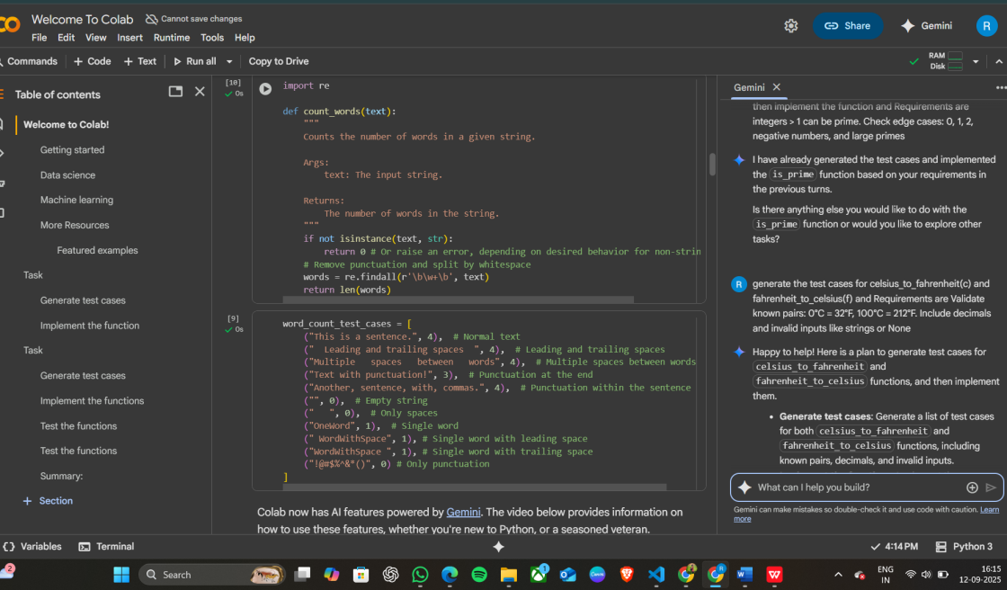  Task Description#4  - Generate test cases for a BankAccount class with:  Methods:  deposit(amount)  withdraw(amount)  check_balance()  Requirements:  - Negative deposits/withdrawals should raise an error.  - Cannot withdraw more than balance.  Expected Output#4  - AI-generated test suite with a robust class that handles all test cases.  - 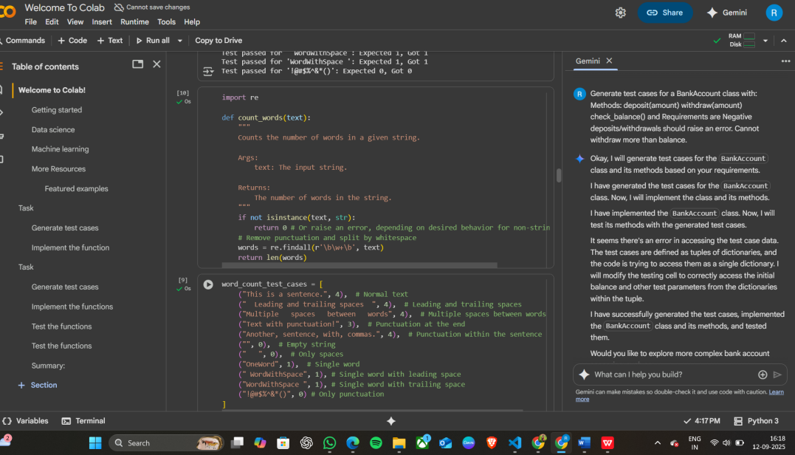  Task Description#5  Generate test cases for is_number_palindrome(num), which checks if an integer reads the same backward.  Examples:  121 → True  123 → False  0, negative numbers → handled gracefully  Expected Output#5  - Number-based palindrome checker function validated against test cases.  - 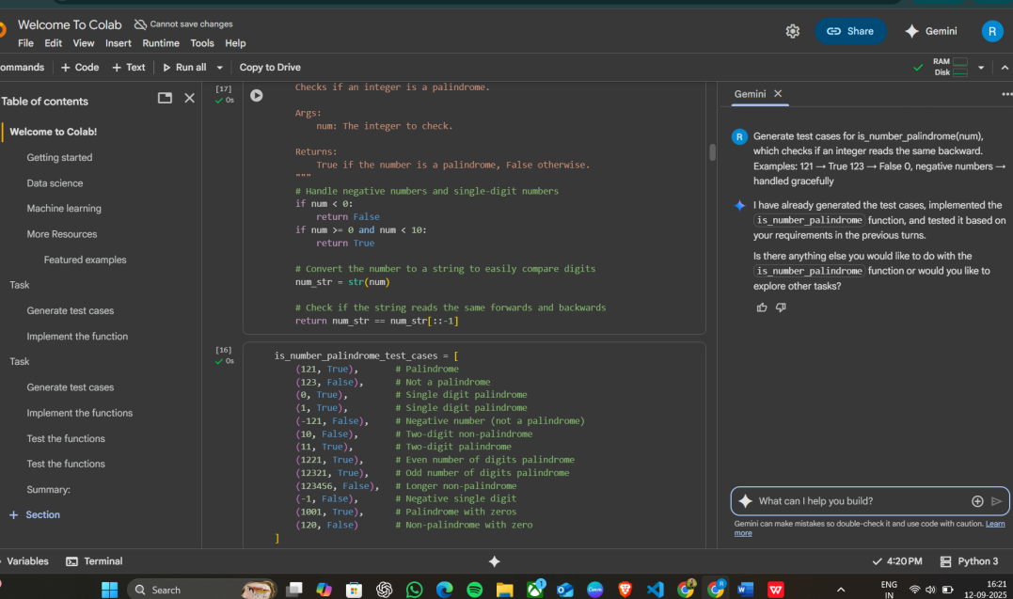  Note: Report should be submitted a word document for all tasks in a single document with prompts, comments & code explanation, and output and if required, screenshots  Evaluation Criteria:  Criteria Max Marks  Task #1 0.5  Task #2 0.5  Task #3 0.5  Task #4 0.5  Task #5 0.5  Total 2.5 Marks |  |  |  |  |  | Week4 - Wednesday

